**MCT-313L: HYDRAULICS AND PNEUMATICS LAB**

________________________________________



**PNEUMATICS-BASED STAMPING SYSTEM**

# SUBMITTED TO:

# Sir Amir Shareef

**SUBMITTED BY:**

HASEEB-UL-HASSAN(2022-MC-58)

MUQADDSA BATOOL(2022-MC-69)

ZAINAB (2022-MC-71)

ALISHBA KIYANI (2022-MC-75)

MUTEEBA JAVED (2022-MC-76)

_____________________________________

**Mechatronics and Control Engineering Department**

University of Engineering and Technology, Lahore

# Introduction:

Industrial automation is essential for modern manufacturing, delivering enhanced efficiency, consistency, and scalability. Pneumatic systems, recognized for their simplicity and reliability, significantly contribute to these advancements by using compressed air for precise tasks in packaging, material handling, and assembly lines. This project develops a pneumatic-based stamping system to demonstrate the application of pneumatic technology in industrial automation. It integrates key components, including a conveyor belt for object transport, an infrared (IR) sensor for detection, and a pneumatic cylinder for stamping. Timing controls ensure synchronization between detection and stamping, showcasing core automation principles. The model illustrates how pneumatic systems can improve productivity and precision, serving as both a functional stamping prototype and a foundation for understanding pneumatics in industrial automation.

# Motivation:

The choice to develop a pneumatic stamping system stemmed from several factors, highlighting pneumatics' value in industry. Pneumatic systems are favored for their simplicity and cost-effectiveness, and this project underscores their practical benefits in achieving automation. Demonstrating the interaction between mechanical, electrical, and pneumatic components showcases how these technologies can work together effectively. Stamping processes are common in industries such as packaging, and automating them enhances consistency and reduces labor. Additionally, this project serves as an educational opportunity to explore pneumatics, sensor detection, and timing control, bridging theory and practice to improve industrial workflows.

**Objectives:**

1. **Demonstrate Pneumatic System Applications:** To showcase the practical use of pneumatic systems in industrial automation by designing a stamping mechanism integrated with a conveyor belt and IR sensor.
2. **Enhance Process Automation Understanding:** To illustrate how pneumatic, mechanical, and electronic components can work together seamlessly for precise and efficient task execution.
3. **Provide a Scalable Automation Model:** To create a functional prototype that highlights the potential of pneumatic systems in improving productivity and consistency in real-world manufacturing processes.

# Components:

The model integrates several key components, including a conveyor belt, an infrared (IR) sensor, and a pneumatic cylinder, to execute a stamping operation. The conveyor belt facilitates the movement of objects, while the IR sensor detects the presence of objects and triggers the pneumatic cylinder to stamp them. Timing control mechanisms ensure synchronized operation, stopping the conveyor precisely when an object is detected for accurate stamping.

## Infra-red (IR) Sensor :

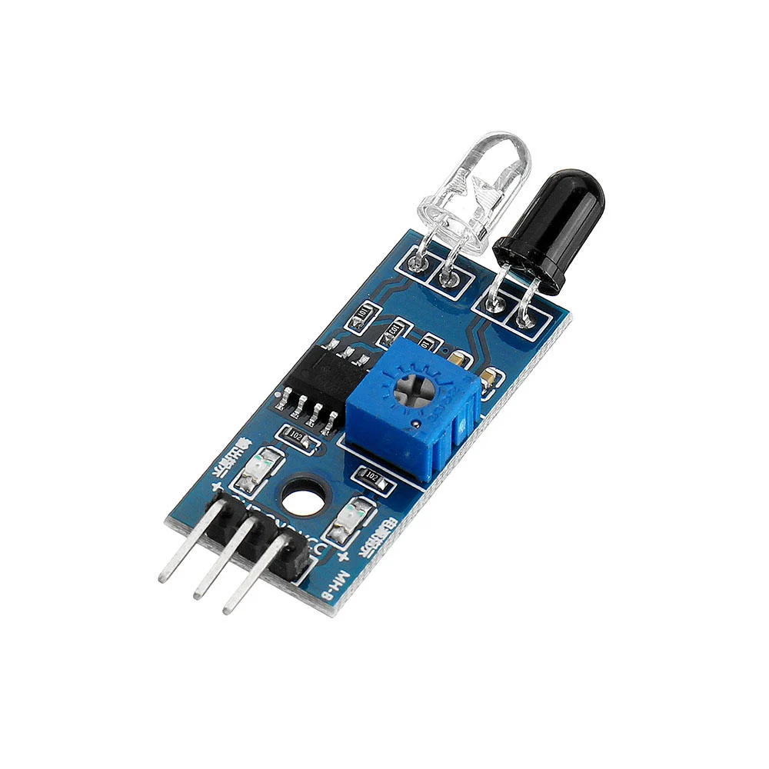

## Working: An IR sensor consists of a pair of infrared transmitting and receiving tubes. The transmitting tube emits infrared light at a specific frequency. When the emitted infrared light encounters an obstacle (a reflective surface), it gets reflected back and is detected by the receiving tube. After processing the signal through a comparator circuit, the green indicator light will turn on. At the same time, the signal output interface will send a digital signal (a low-level signal of 1).

## Specifications:

## Voltage range: 3.3-5V.

## Output: Digital output signal.

## Role in Setup: Detects the presence of object and directs stamping action.

**DC (Geared) Motor:**

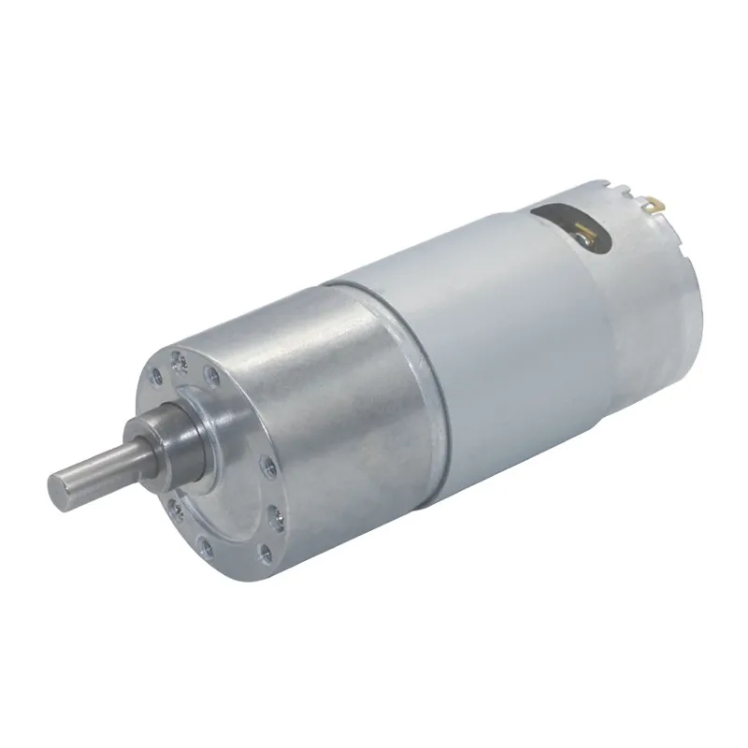

**Description**: A DC gear motor is an electric motor with a gear mechanism attached to it. This combination allows the motor to deliver increased torque while reducing its speed. Commonly used in applications requiring precise movement and high power at lower speeds.

**Specifications**:

* + Voltage range: 12V.
  + KV Rating:
  + Applications: Conveyors. robotic arms.

**Role in Setup:** Provides mechanical power for rollers and moves the conveyor belt

# 24V Relay**:**

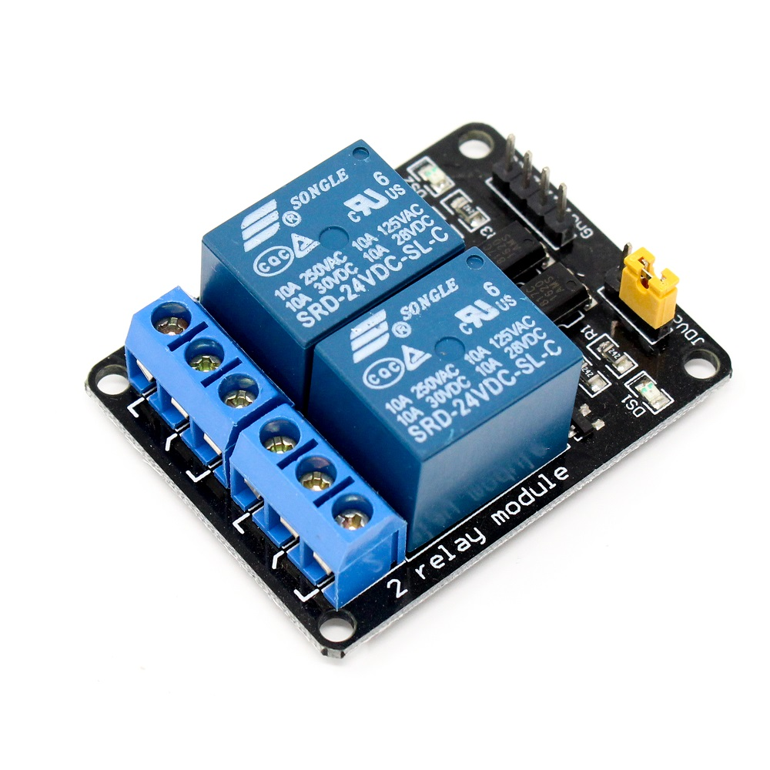Standard 30A BLDC ESC Electronic Speed Controller for BLDC motor for f450 drone frame at best price online in islamabad rawalpindi lahore peshawar faisalabad karachi hyderabad quetta wah taxila PakistanStandard 30A BLDC ESC Electronic Speed Controller for BLDC motor for f450 drone frame at best price online in islamabad rawalpindi lahore peshawar faisalabad karachi hyderabad quetta wah taxila PakistanStandard 30A BLDC ESC Electronic Speed Controller for BLDC motor for f450 drone frame at best price online in islamabad rawalpindi lahore peshawar faisalabad karachi hyderabad quetta wah taxila PakistanStandard 30A BLDC ESC Electronic Speed Controller for BLDC motor for f450 drone frame at best price online in islamabad rawalpindi lahore peshawar faisalabad karachi hyderabad quetta wah taxila PakistanStandard 30A BLDC ESC Electronic Speed Controller for BLDC motor for f450 drone frame at best price online in islamabad rawalpindi lahore peshawar faisalabad karachi hyderabad quetta wah taxila PakistanStandard 30A BLDC ESC Electronic Speed Controller for BLDC motor for f450 drone frame at best price online in islamabad rawalpindi lahore peshawar faisalabad karachi hyderabad quetta wah taxila PakistanStandard 30A BLDC ESC Electronic Speed Controller for BLDC motor for f450 drone frame at best price online in islamabad rawalpindi lahore peshawar faisalabad karachi hyderabad quetta wah taxila PakistanStandard 30A BLDC ESC Electronic Speed Controller for BLDC motor for f450 drone frame at best price online in islamabad rawalpindi lahore peshawar faisalabad karachi hyderabad quetta wah taxila PakistanStandard 30A BLDC ESC Electronic Speed Controller for BLDC motor for f450 drone frame at best price online in islamabad rawalpindi lahore peshawar faisalabad karachi hyderabad quetta wah taxila PakistanStandard 30A BLDC ESC Electronic Speed Controller for BLDC motor for f450 drone frame at best price online in islamabad rawalpindi lahore peshawar faisalabad karachi hyderabad quetta wah taxila PakistanStandard 30A BLDC ESC Electronic Speed Controller for BLDC motor for f450 drone frame at best price online in islamabad rawalpindi lahore peshawar faisalabad karachi hyderabad quetta wah taxila PakistanStandard 30A BLDC ESC Electronic Speed Controller for BLDC motor for f450 drone frame at best price online in islamabad rawalpindi lahore peshawar faisalabad karachi hyderabad quetta wah taxila Pakistan

**Description**: A 24V relay is an electromechanical switch that uses DC input to control the operation of its internal switching mechanism. It allows low-power control signals to manage higher-power circuits safely and efficiently. Commonly used in automation, control systems, and industrial applications.

**Specifications**:

* + Voltage rating: 24V (maximum).

**Role in Setup**:Enable reliable switching of motor.

**Switch:**

## ESP 8266:

The ESP8266 is a low-cost Wi-Fi microchip with built-in TCP/IP networking capabilities. It is widely used in IoT (Internet of Things) projects and applications to enable devices to connect and communicate over a network. Equipped with a powerful processor and multiple GPIO pins, the ESP8266 can be programmed to control sensors, relays, and other components, making it ideal for smart automation systems.

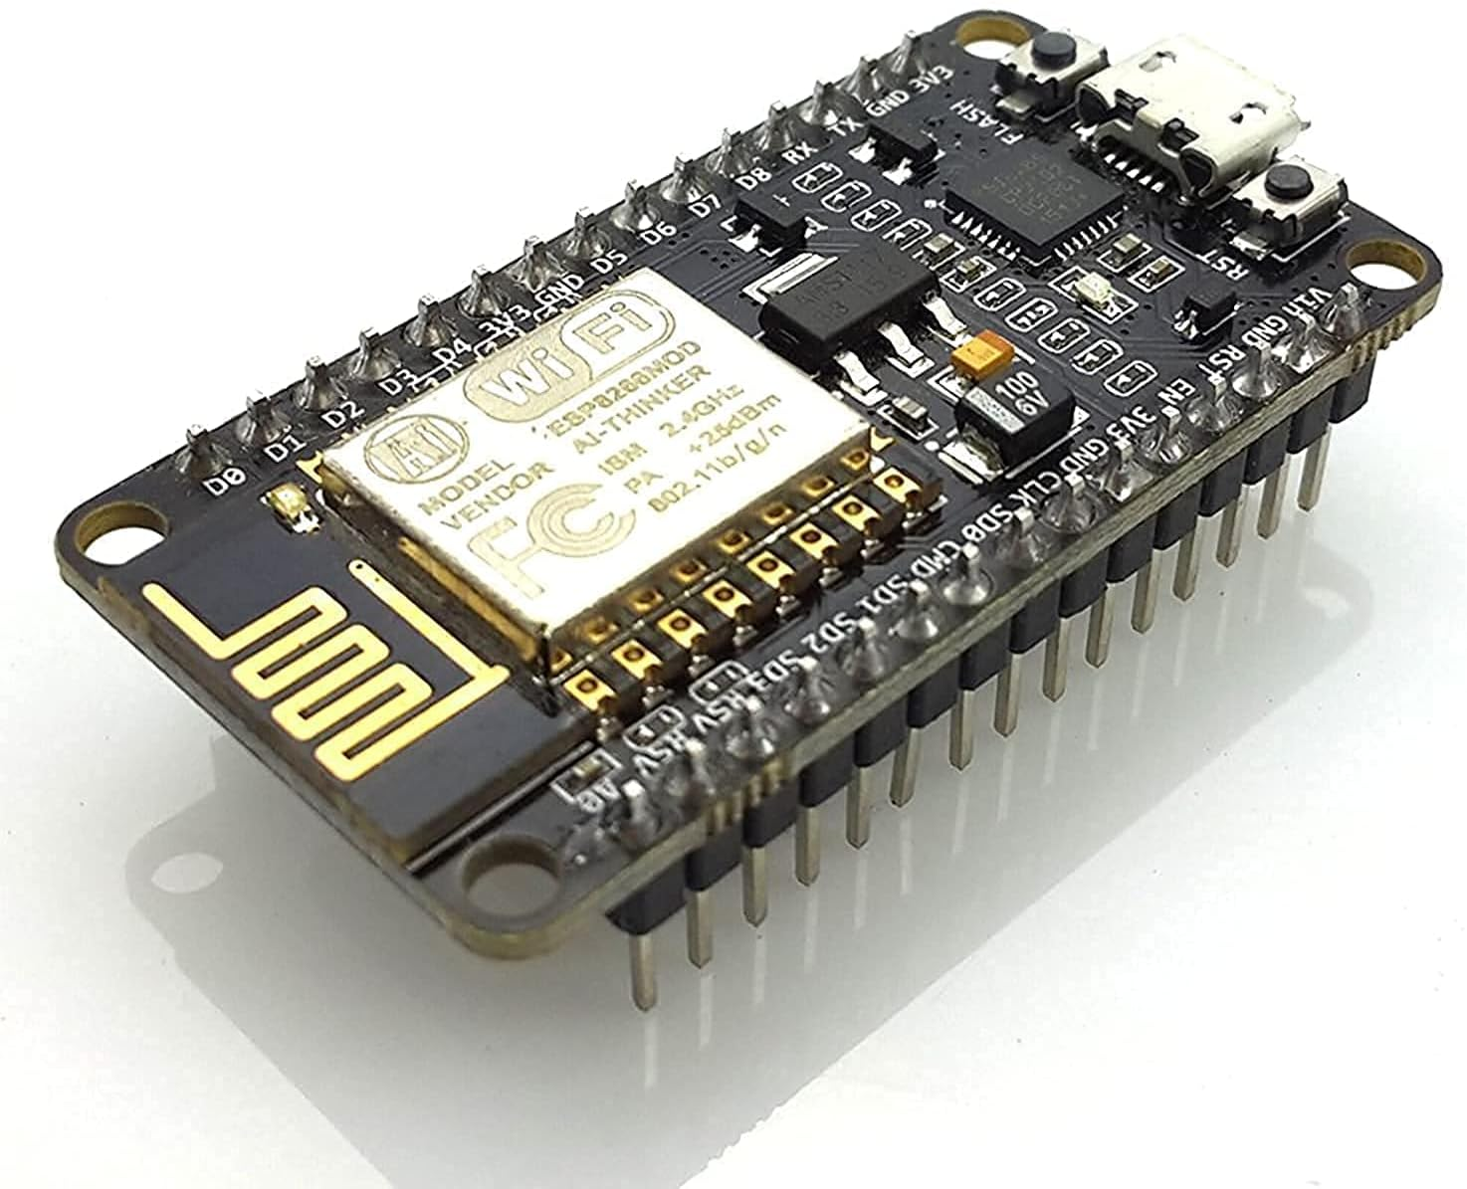

**3. Methodology:**

**3.1. System Setup**

**3.2. Data Collection:**

# CONNECTION CONFIGURATION:

The following are the configuration of pinouts of all the components used:

| **Sr No.** | **COMPONENT** | **TIVA PIN CONFIGURATION** | |
| --- | --- | --- | --- |
|  | ACS712 Current Sensor (30A): | PE2 | |
|  | A2212 Brushless DC BLDC | PE4 | |
|  | 16x2 Liquid Crystal Display (LCD) | D4 | PB4 |
| D5 | PB5 |
| D6 | PB6 |
| D7 | PB7 |
| RS | PB0 |
| RW | PB1 |
| EN | PB2 |
| 4. | POTENTIOMETER | PE3 | |
| 5. | OPTOCOUPLER | PB3 | |

# FUNCTIONALITY OF GPIO PINS USED:

**FLOWCHART:**

**CODE AND LIBRARIES USED:**

# circuit Schematics:

The following is the circuit diagram and the layout of it:

## PROJECT HARDWARE:

The following below is the HARDWARE of the whole setup:

# Bill of Material:

| **Sr No.** | **COMPONENT** | **DESCRIPTION** | **UNIT PRICE** | **QUANTITY** | **TOTAL PRICE** | **VENDOR** | **STATUS** |
| --- | --- | --- | --- | --- | --- | --- | --- |
| 1 | DC GEAR MOTOR | 12V motor | 300 | 1 | 300 | Digilog electronics  Ph no.03269776381 | Active |
| 2 | IR SENSOR | OBJECT DETECTION | 110 | 1 | 110 | Digilog electronics  Ph no.03269776381  Epro electronics  Ph no.03015755775 | Active |
| 3 | RELAY | 24V RATING | 135 | 2 | 270 | Digilog electronics  Ph no.03269776381  Epro electronics  Ph no.03015755775 | Active |
| 4 | ESP 8266 | AS MICRO-  CONTROLLER | 850 | 1 | 850 | Digilog electronics  Ph no.03269776381 | Active |
| 5 | 5V DC POWER SUPPLY ADAPTER | 5V, 2AMP | 170 | 1 | 170 | Epro electronics  Ph no.03015755775 | Active |
| 6 | DC TO DC BOOST CONVERTER | AMPLIFIER BOARD | 150 | 1 | 150 | Epro electronics  Ph no.03015755775 | Active |
| 7 | SWITCH |  |  | 1 | 20 | Epro electronics  Ph no.03015755775 | Active |
| 8 | PLASTIC SHEET | For conveyor | 100 | 1 | 100 |  | Active |
| 9 | wooden blocks | For conveyor | 400 |  |  |  |  |
| 10 | pneumatic cylinder | For Stamping | 1500 | 1 | 1500 |  | Active |
| 11 | stamp |  |  |  |  |  |  |